Pi-mono Installation & Quick Start Guide

Overview
You will complete these steps:
- Install Node.js
- Install pi-mono
- Install a local AI model (Ollama)
- Connect pi-mono to the model
- Run your first agent task

Step 1: Install Node.js
pi-mono requires Node.js (version 20 or newer).

macOS / Windows
Download and install Node.js (LTS version):
https://nodejs.org
After installation, open Terminal (or PowerShell) and check: (input node -v , then, press Enter)
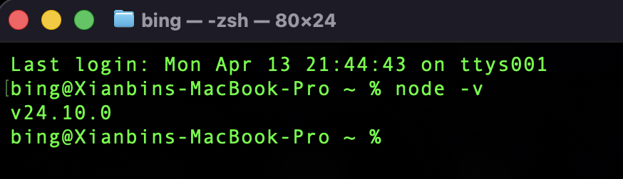

Step 2: Install pi-mono
Install pi-mono globally: input the following into the Terminal (or PowerShell); it will install pi for you.
npm install -g @mariozechner/pi-coding-agent

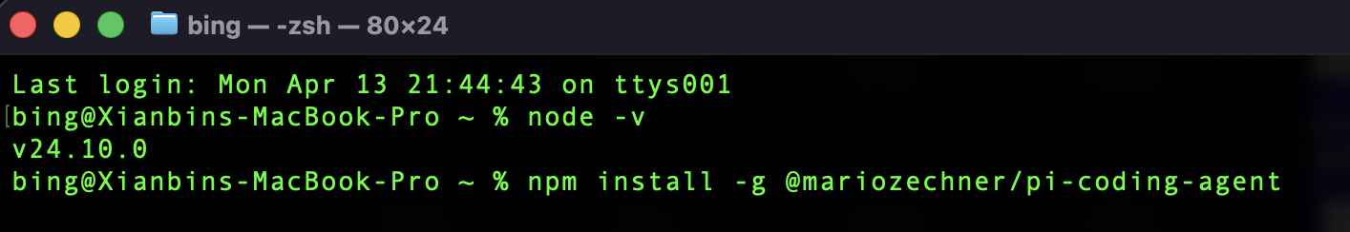
To check your installation, please input pi --help in the Terminal, and if the help information appears, installation is successful.
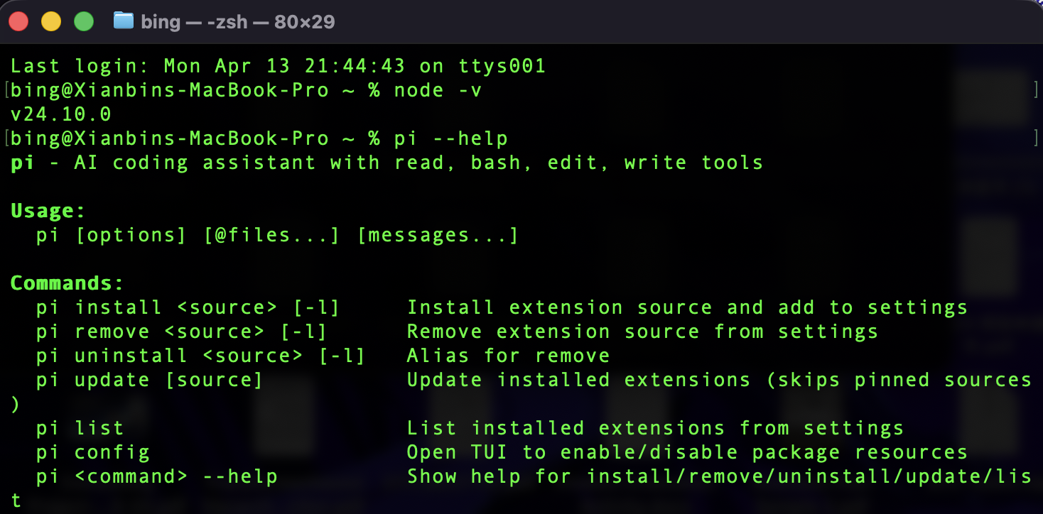

Step 3: Install Ollama (Local AI Model)
pi-mono needs an AI model to function. The easiest option is Ollama, which runs models locally.
Please following the instructions in this link to install Ollama: ​​Ollama Installation & Quick Start Guide. If you have already installed Ollama, please ignore this step.

Step 4: Configure pi-mono to Use Ollama
Create a configuration directory: input the following in the Terminal
mkdir -p ~/.pi/agent
Then, create a configuration file:
nano ~/.pi/agent/models.json
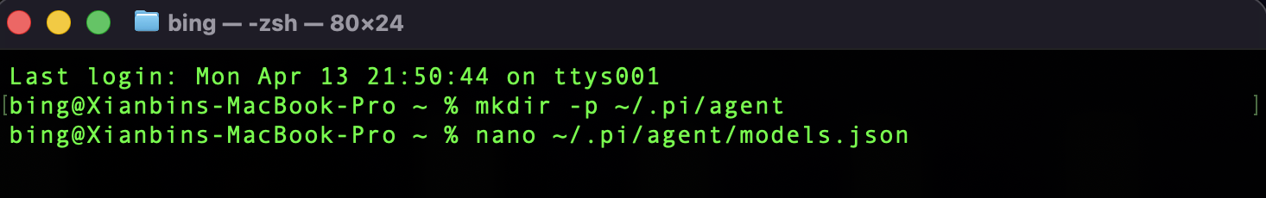
Paste the following into the file:
{
"providers": {
"ollama-local": {
"baseUrl": "http://127.0.0.1:11434/v1",
"api": "openai-completions",
"apiKey": "ollama",
"compat": {
"supportsDeveloperRole": false,
"supportsReasoningEffort": false
},
"models": [
{ "id": "phi4-mini:latest" }
]
}
}
}
Press ctl+x to save and exit.
Note:
"models": [
{ "id": "phi4-mini:latest" }, ← the local model in your Ollama
{ "id": "qwen3.5:9b" }, ← you can add more local models here
]
There are models available at https://ollama.com/search; Only those that have the tag tool can work with the Agents like pi-mono:
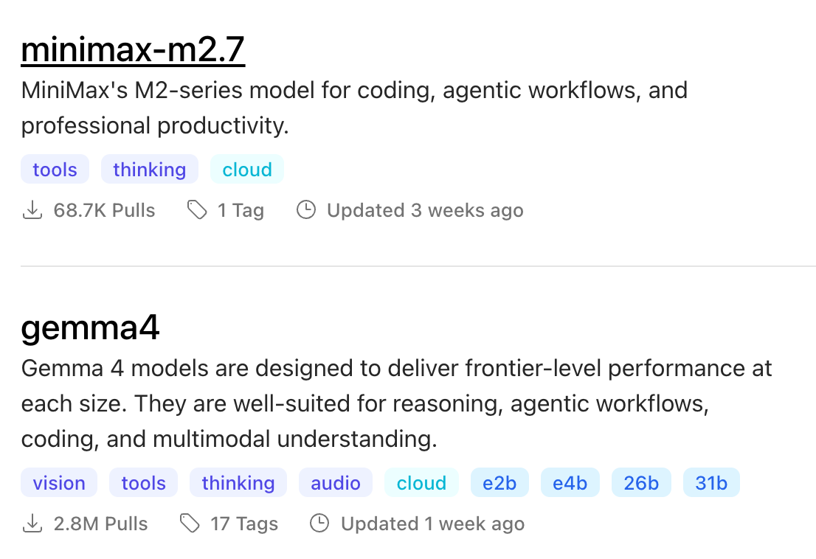
Remember to use ollama list to see your local models:
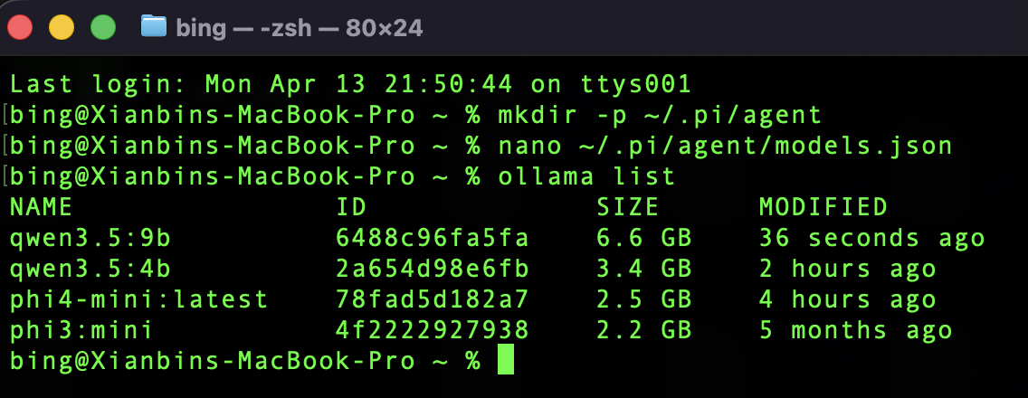

Step 5: Start pi-mono
Input pi in your terminal it will start the pi. 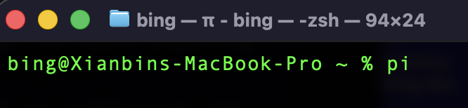
Then, input /model to choose a model
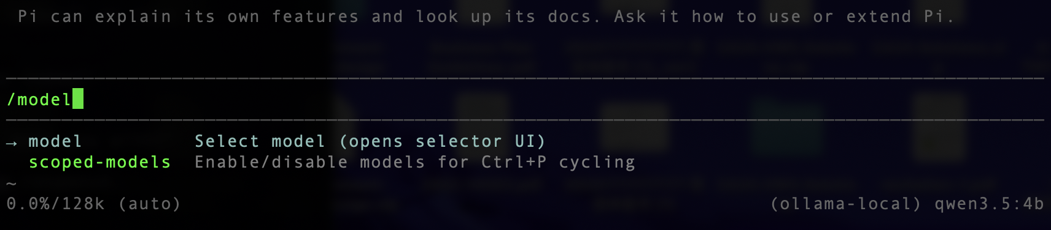
It lists the local models you added in the models.json above. You can press Esc to quit the current command.
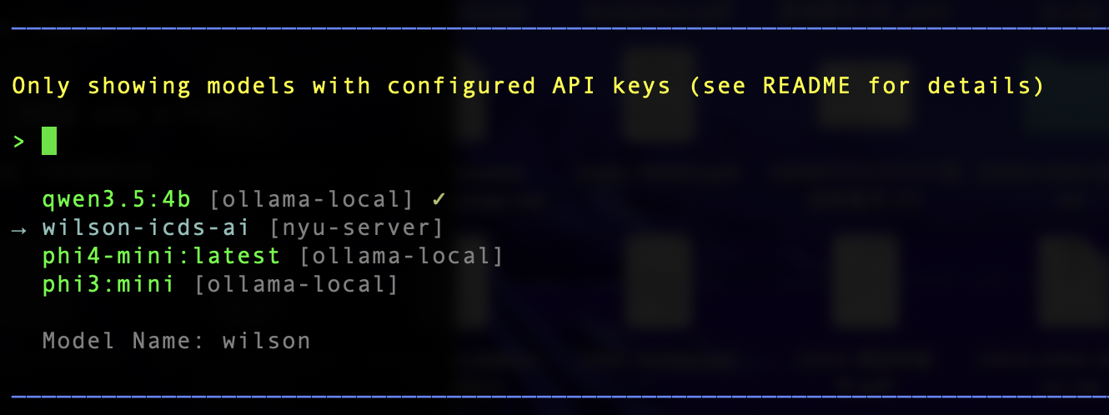

After you select the model, congratulations! the Agent is alive 😀! You can talk to it, and ask it to do coding tasks.

If you want to quit pi and go back to the Terminal command line, please press ctrl + d.

Step 6: Run pi-mono Inside a Project Folder (Recommended)
You can open a project folder using VS Code, then, in the terminal input pi to start the pi in your project. Now all generated files will be saved inside this folder.

For example, if you start pi in the chat_system project, you can input “explain the code of indexer.py”, and see what the agent will do.
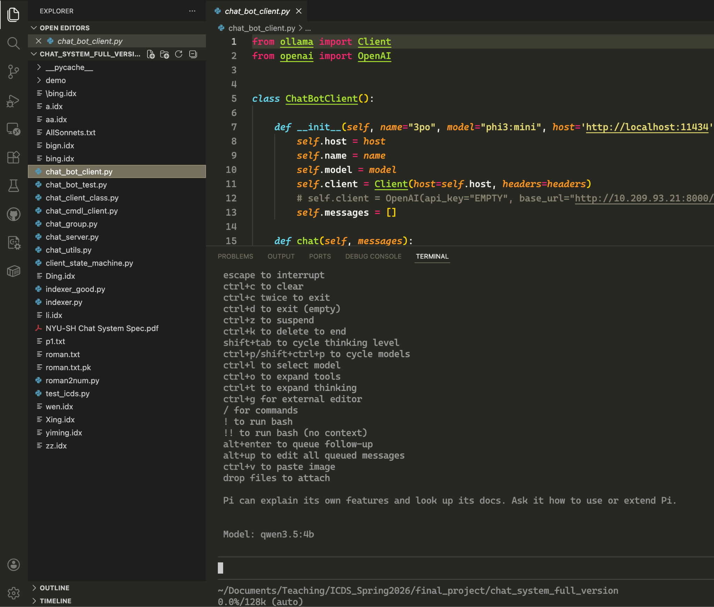

Step 7: Using Remote LLMs (Optional)
pi allows you to use the LLMs on the cloud such as ChatGPT, Claude, Copilot. You can input your /login to set up them. (You may be asked to provide your api-key to get authorized.)
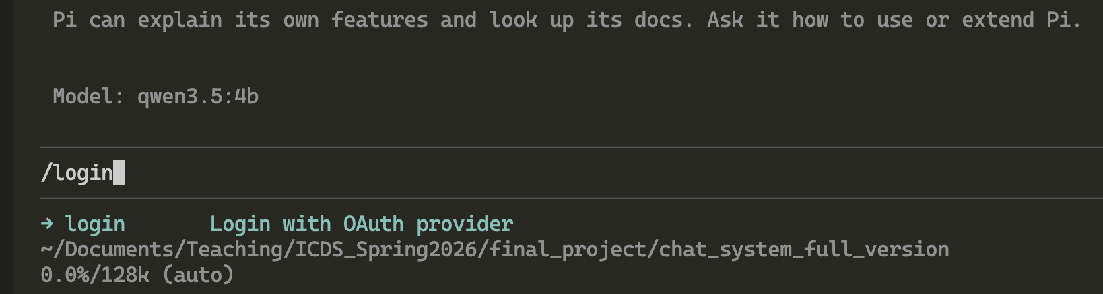
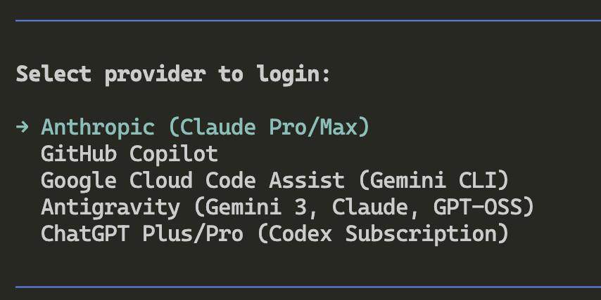

You can also use your own remote LLMs. Below is an example showing how to add your own remote LLMs. The “nyu-server” is a model deployed on Prof. Tam’s server (and he opens it to all ICDS students 😀🎉). You can copy and paste the settings of the “nyu-server” into your models.json to use it as your Agent’s brain.

{
"providers": {
"ollama-local": {
"baseUrl": "http://127.0.0.1:11434/v1",
"api": "openai-completions",
"apiKey": "ollama",
"compat": {
"supportsDeveloperRole": false,
"supportsReasoningEffort": false
},
"models": [
{ "id": "phi4-mini:latest" },
{"id": "phi3:mini"},
{"id": "qwen3.5:4b"}
]
},
"nyu-server": {
"baseUrl": "http://10.208.2.89:8002/v1",
"api": "openai-completions",
"apiKey": "dummy",
"compat": {
"supportsDeveloperRole": false,
"supportsReasoningEffort": false
},
"models": [
{
"id": "q3",
"name": "wilson"
}
]
}
}
}

